Single Table Queries

Q1.) List the owner number, last name and first name of every condo owner

SQL CODE:
SELECT OWNER_NUM, LAST_NAME, FIRST_NAME
FROM OWNER;
Screenshot of Table:
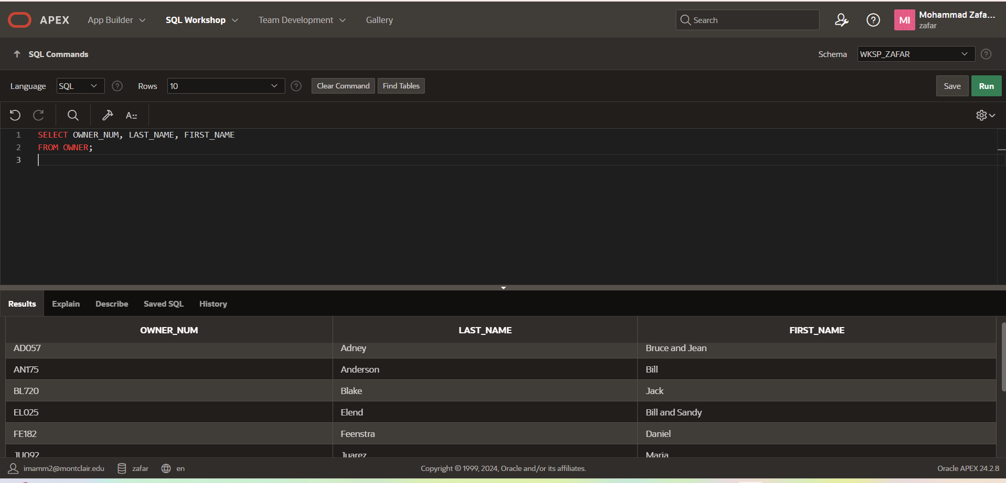

Q2.) List the complete location table (all rows and all columns)
SQL CODE:
SELECT *
FROM LOCATION;
Screenshot of Table:
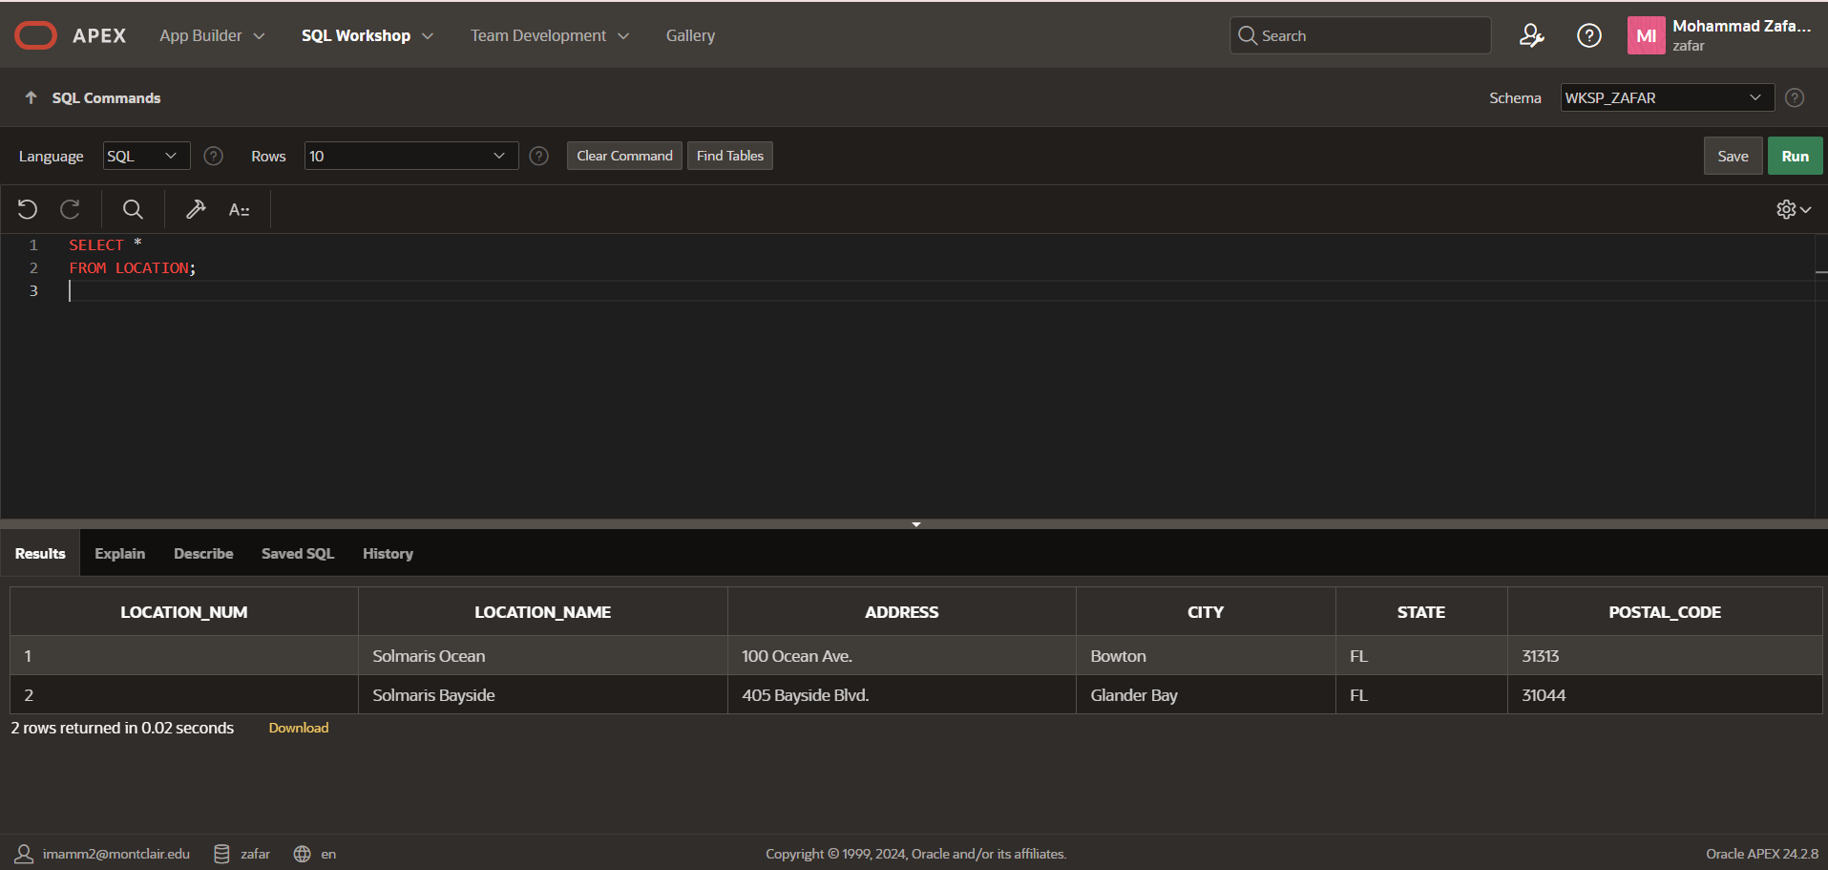

Q3.)List the last name and first name of every owner who lives in Bowton.
SQL CODE:
SELECT *
FROM Owner
Where City = 'Bowton';
Screenshot of Table:
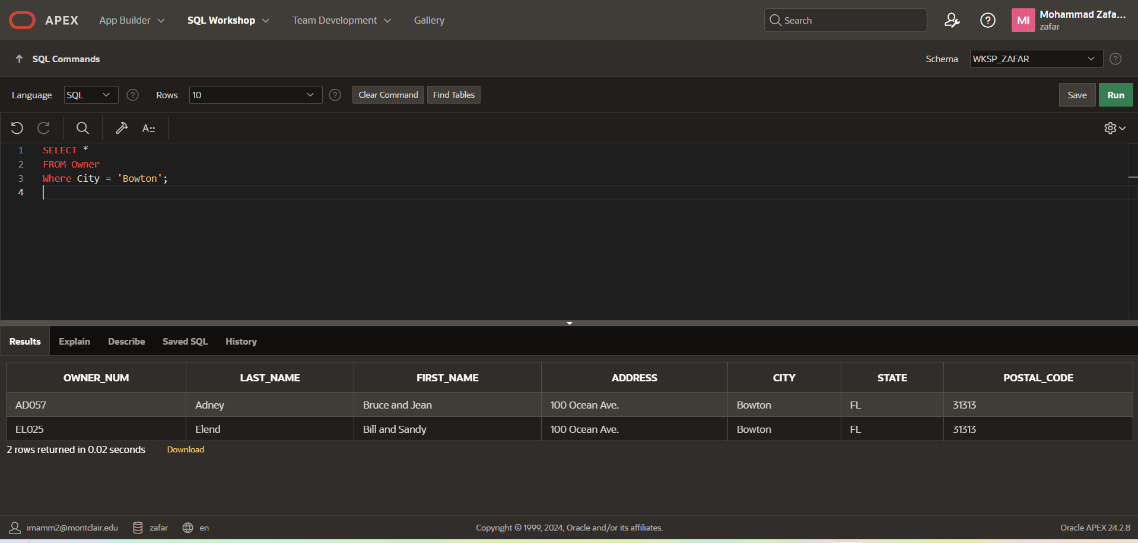

Q4.)List the last name and first name of every owner who doesn't live in Bowton.
SQL CODE:
SELECT *
FROM Owner
Where City != 'Bowton';
Screenshot of Table:
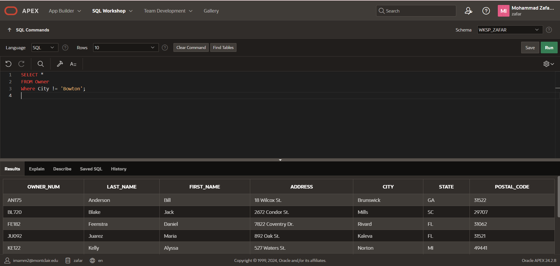

Q5: List the location number and unit number for every condo whose square footage is equal to or less than 1,200 square feet

SQL CODE:
SELECT Location_NUM, Unit_NUM
FROM Condo_Unit
Where SQR_FT <= 1200;
Screenshot of Table:
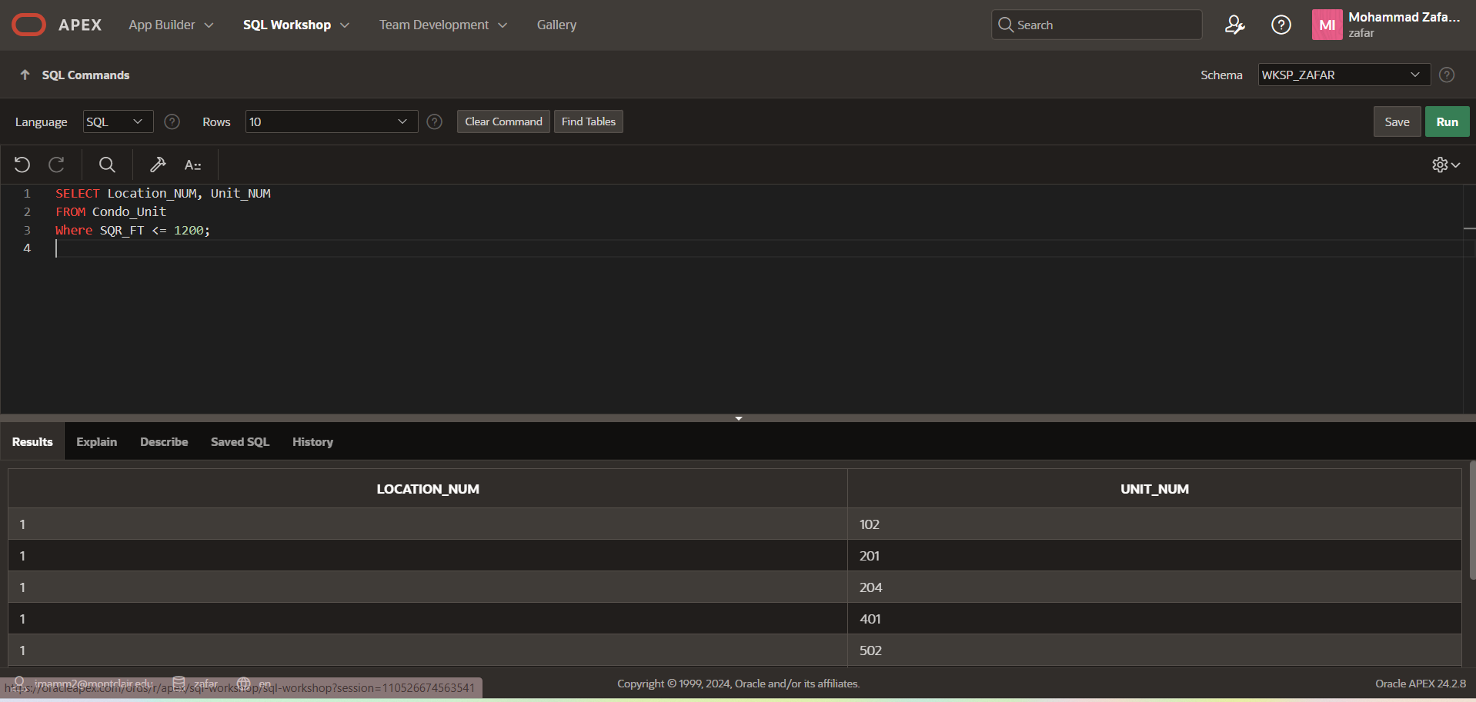

Q6.) List the location number and unit number for every condo with three bedrooms
SQL CODE:
SELECT Location_NUM, Unit_NUM
FROM Condo_Unit
Where Bdrms = 3;
Screenshot of Table:
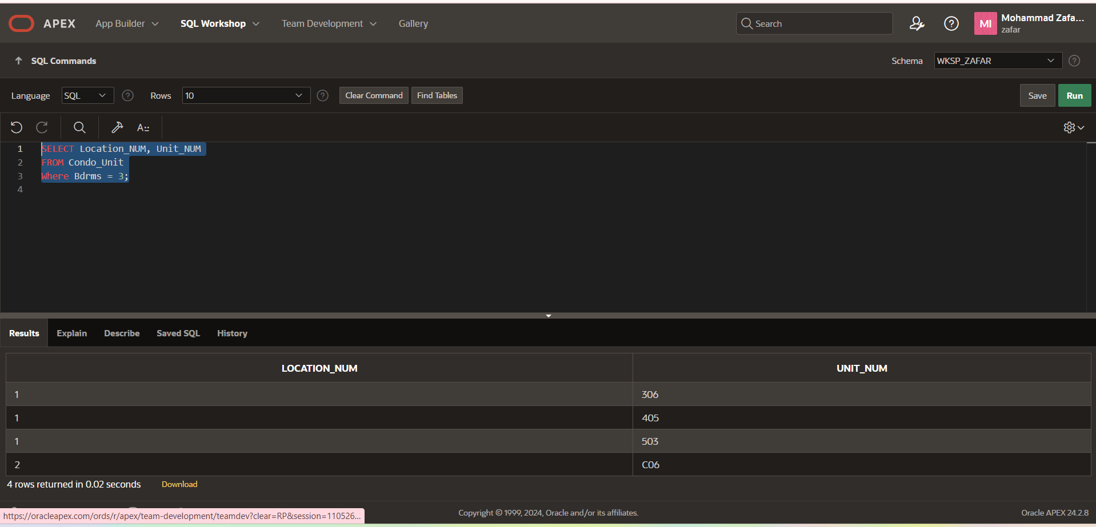
Q.7) List the unit number of every condo with two bedrooms that is located in location number 2?
SQL CODE:
SELECT Unit_NUM
FROM Condo_Unit
Where Bdrms = 2
And Location_NUM = 2;

Screenshot of Table:
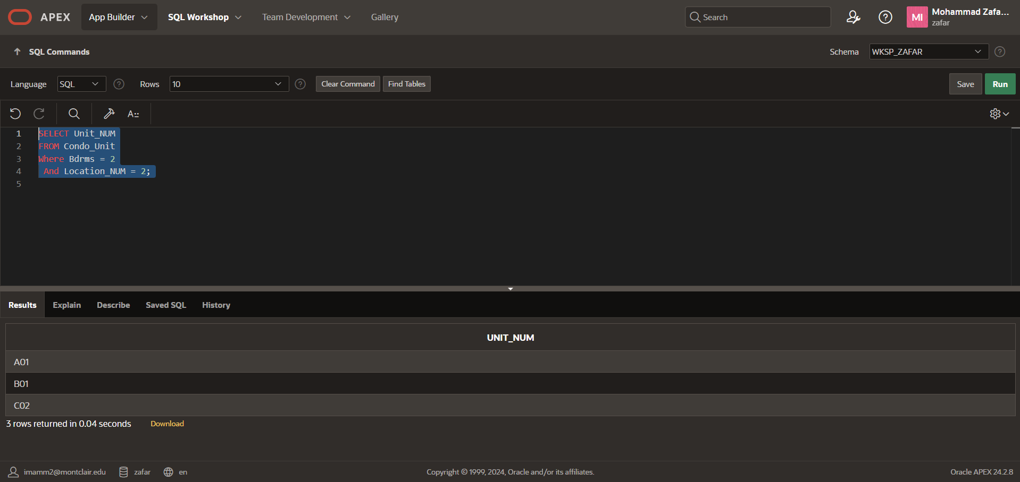

Q.8) List the condo id for every condo with a condo fee that is between $550 & $650.
SQL CODE:
SELECT CONDO_ID
FROM CONDO_UNIT
WHERE CONDO_FEE BETWEEN 550 AND 650;
Screenshot of Table:
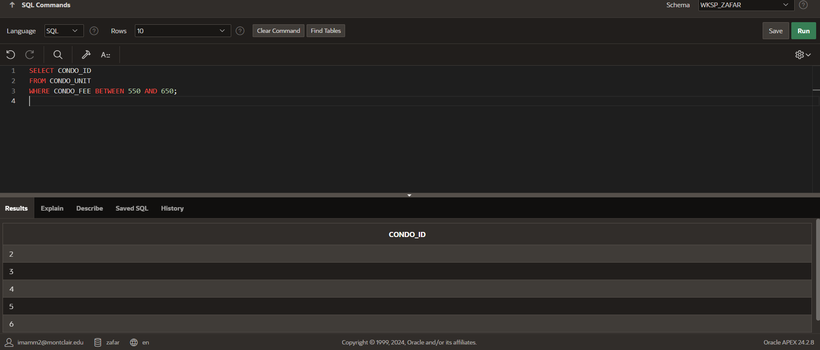

Q.9). List the unit number for every condo in location number 1 whos condo fee is less than $500
SQL CODE:
SELECT Unit_NUM
FROM CONDO_UNIT
WHERE CONDO_FEE < 500 AND Location_Num = 1;
Screenshot of Table:
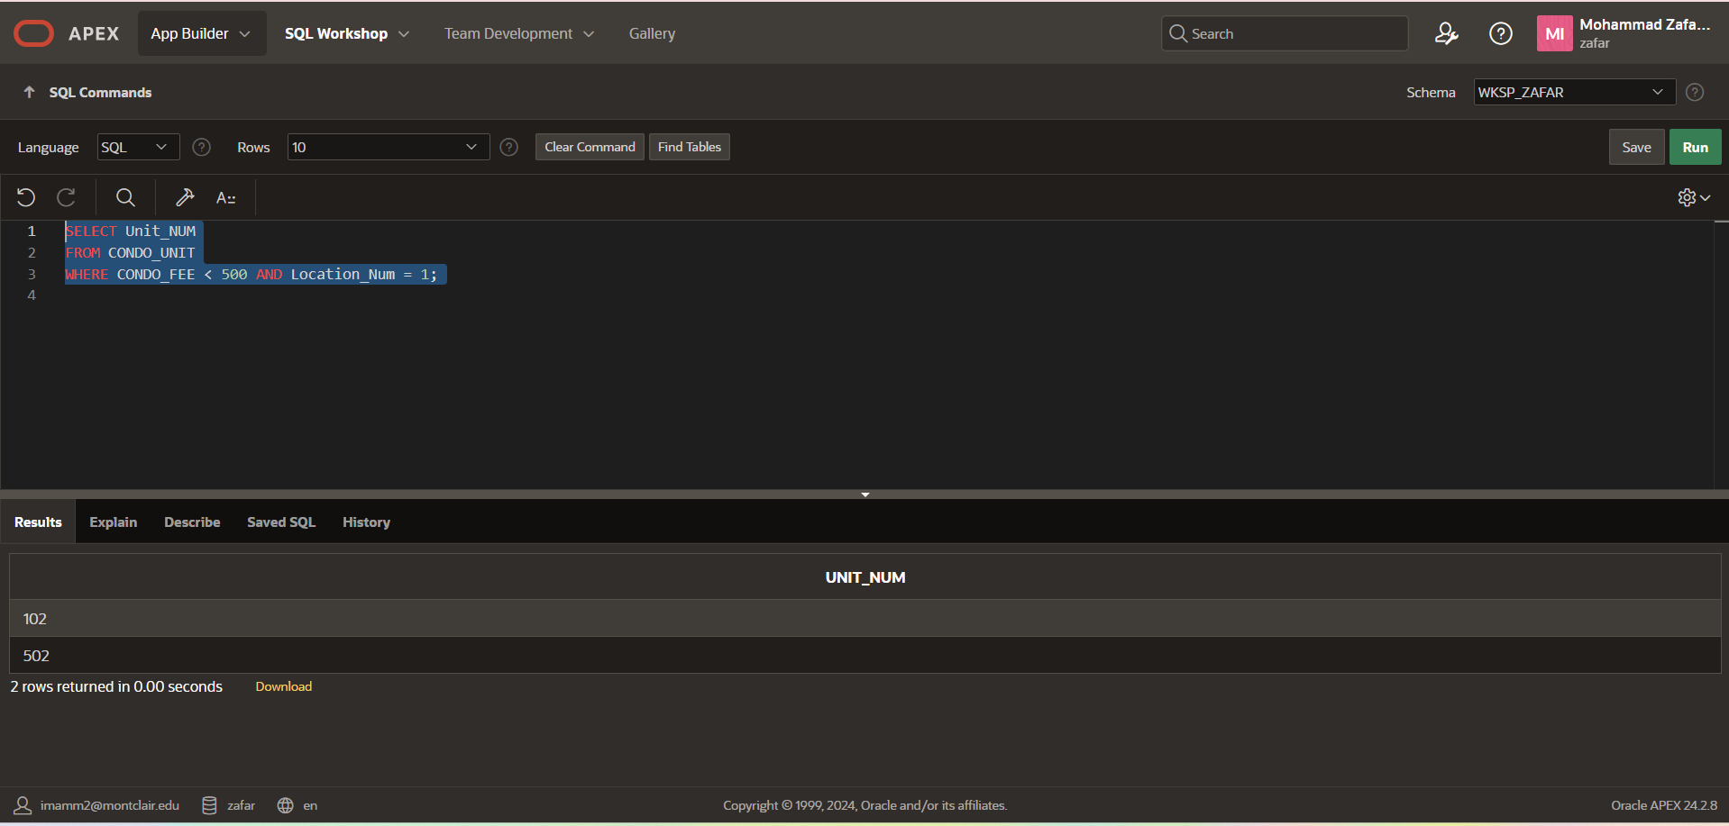

Q.10 ) Labor is billed at the rate of $35 per hour. List each service request’s condo ID, category number, estimated hours, and estimated labor cost. To calculate the estimated labor cost, multiply the estimated hours by 35 and present it in a column named ESTIMATED_COST.

SQL CODE:
SELECT
CONDO_ID,
CATEGORY_NUM,
EST_HOURS,
EST_HOURS * 35 AS ESTIMATED_COST
FROM SERVICE_REQUEST;
Screenshot of Table:
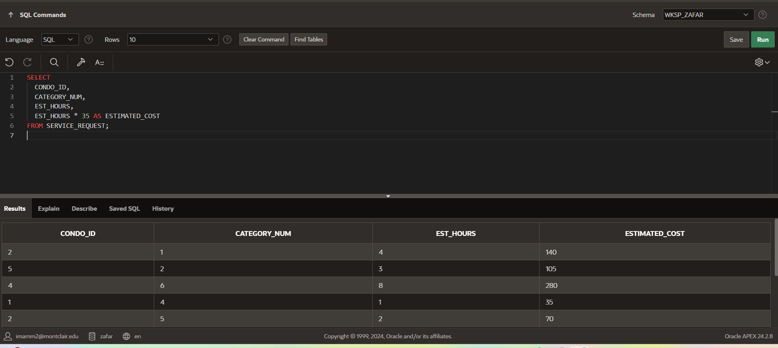

Q.11)List the owner number and last name for all condo owners whose state is Florida (FL), Georgia (GA), or South Carolina (SC)

SQL CODE:
SELECT Owner_NUM, Last_Name
FROM Owner
Where State IN ('FL', 'GA', 'SC');
Screenshot of Table:
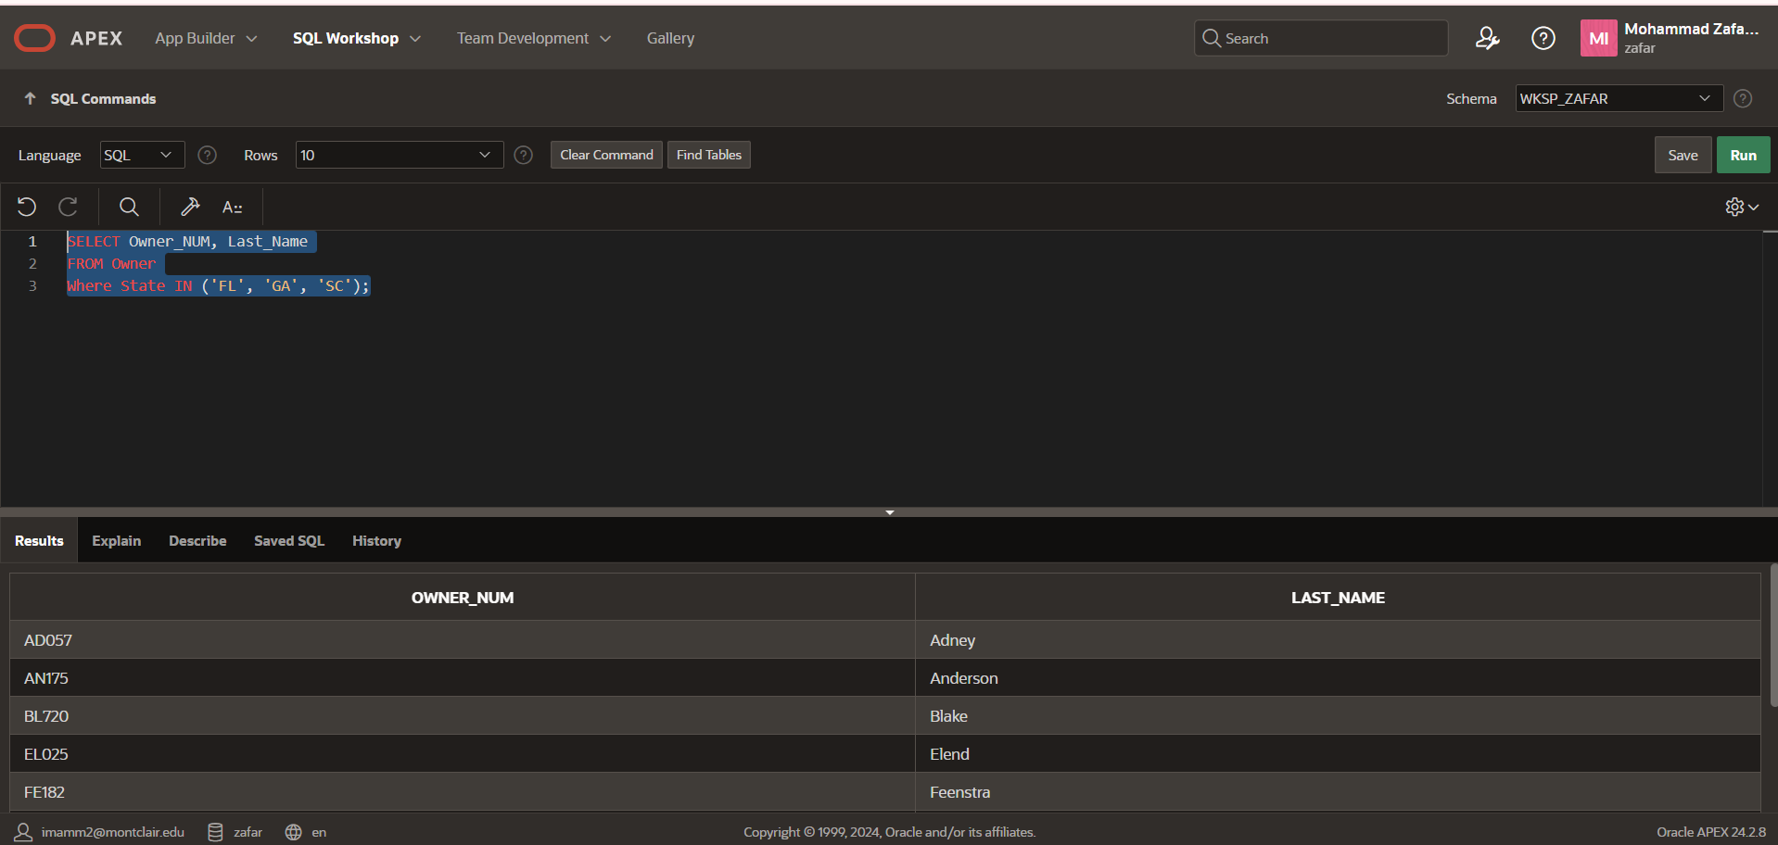

Q.12). List each unit’s location number, unit number, square footage, and condo fee for all condo units. Sort the results first by square footage, and within each square footage, by condo fee.

SQL CODE:
SELECT
LOCATION_NUM,
UNIT_NUM,
SQR_FT,
CONDO_FEE
FROM CONDO_UNIT
ORDER BY
SQR_FT,
CONDO_FEE;

Screenshot of Table:

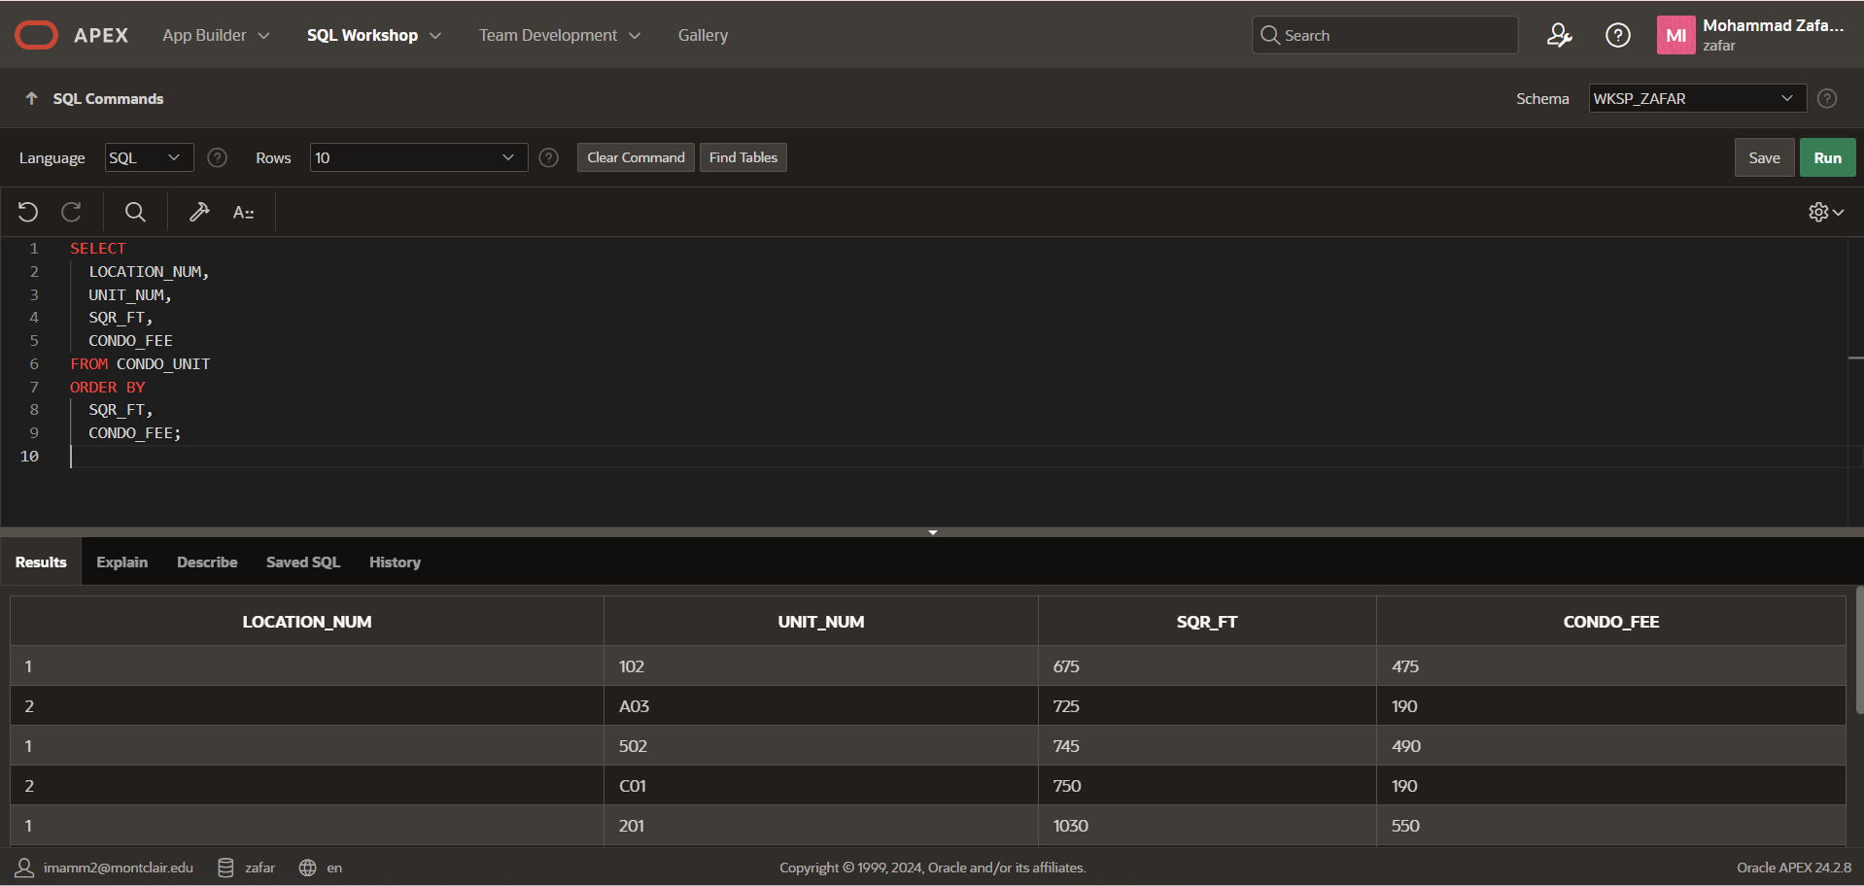

Q13.) How many one bedroom condos are located at each locations?
SQL CODE:
SELECT
LOCATION_NUM,
COUNT(*) AS ONE_BEDROOM_COUNT
FROM CONDO_UNIT
WHERE BDRMS = 1
GROUP BY LOCATION_NUM
ORDER BY LOCATION_NUM;

Screenshot of Table:
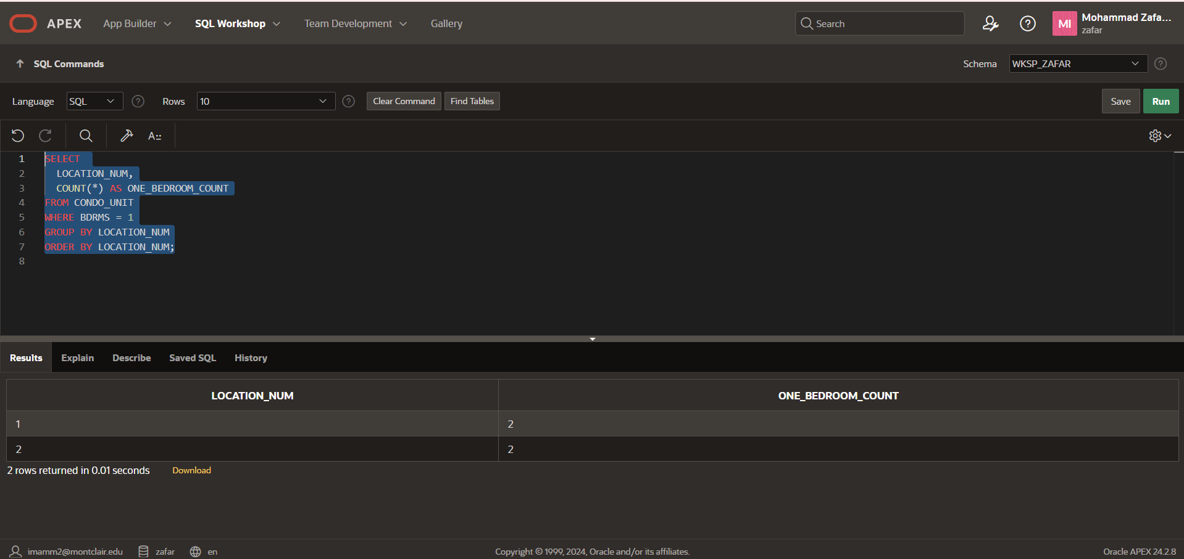

Q.14) Calculate the total amount of condo fees that Solmaris Condominium Group collects each month from all condo units combined.
Code:
SELECT SUM(CONDO_FEE) AS TOTAL_MONTHLY_FEES
FROM CONDO_UNIT;
Screenshot of Table:
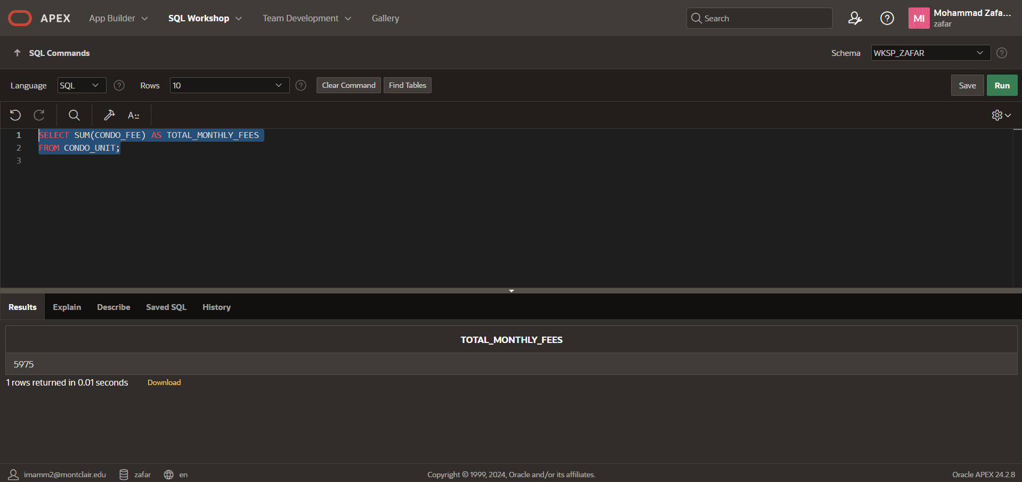

Q15.) There are two ways to create the query from Step 11 (which asked to list owner number and last name for all owners who live in Florida (FL), Georgia (GA), or South Carolina (SC)). Write the SQL command that you used and then write an alternate command that would also obtain the correct result.
SQL Command That I used:
SQL CODE:
SELECT Owner_NUM, Last_Name
FROM Owner
Where State IN ('FL', 'GA', 'SC');
Screenshot of Table:


Alternate SQL Command:
SQL CODE:
SELECT OWNER_NUM, LAST_NAME
FROM OWNER
WHERE STATE = 'FL'
OR STATE = 'GA'
OR STATE = 'SC';

Screenshot of Table:

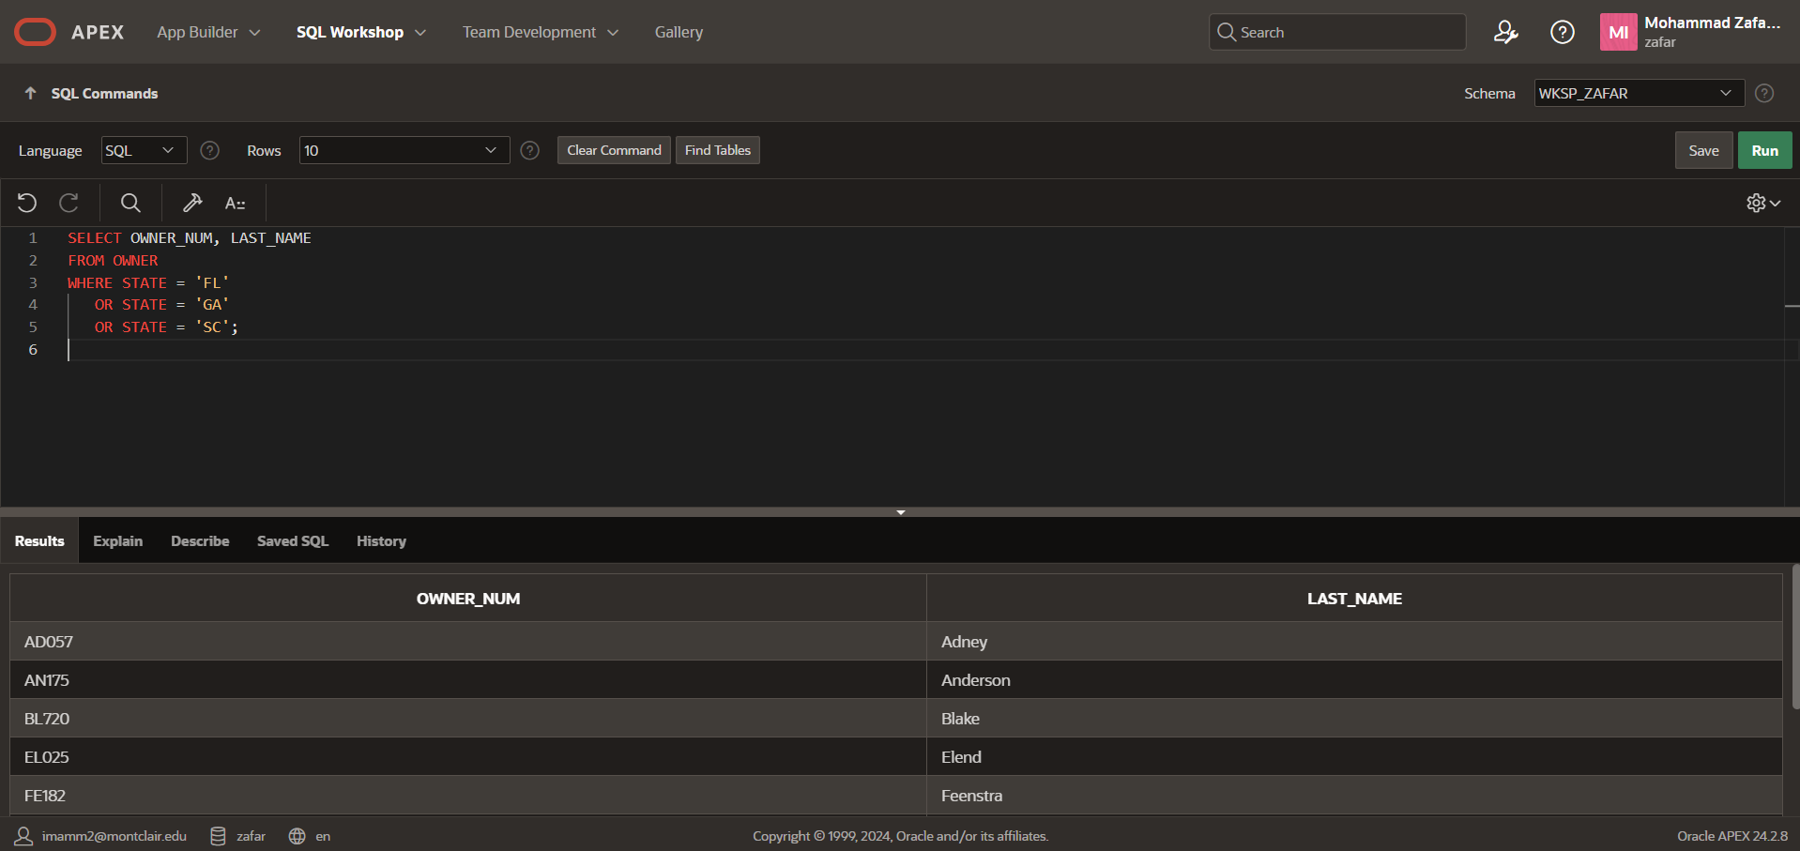

Q.16) What WHERE clause would you use to find all service requests whose Description field contains the word “pantry” anywhere in the text?
SQL CODE:
SELECT *
FROM SERVICE_REQUEST
WHERE Description LIKE '%party%';

Screen Shot:
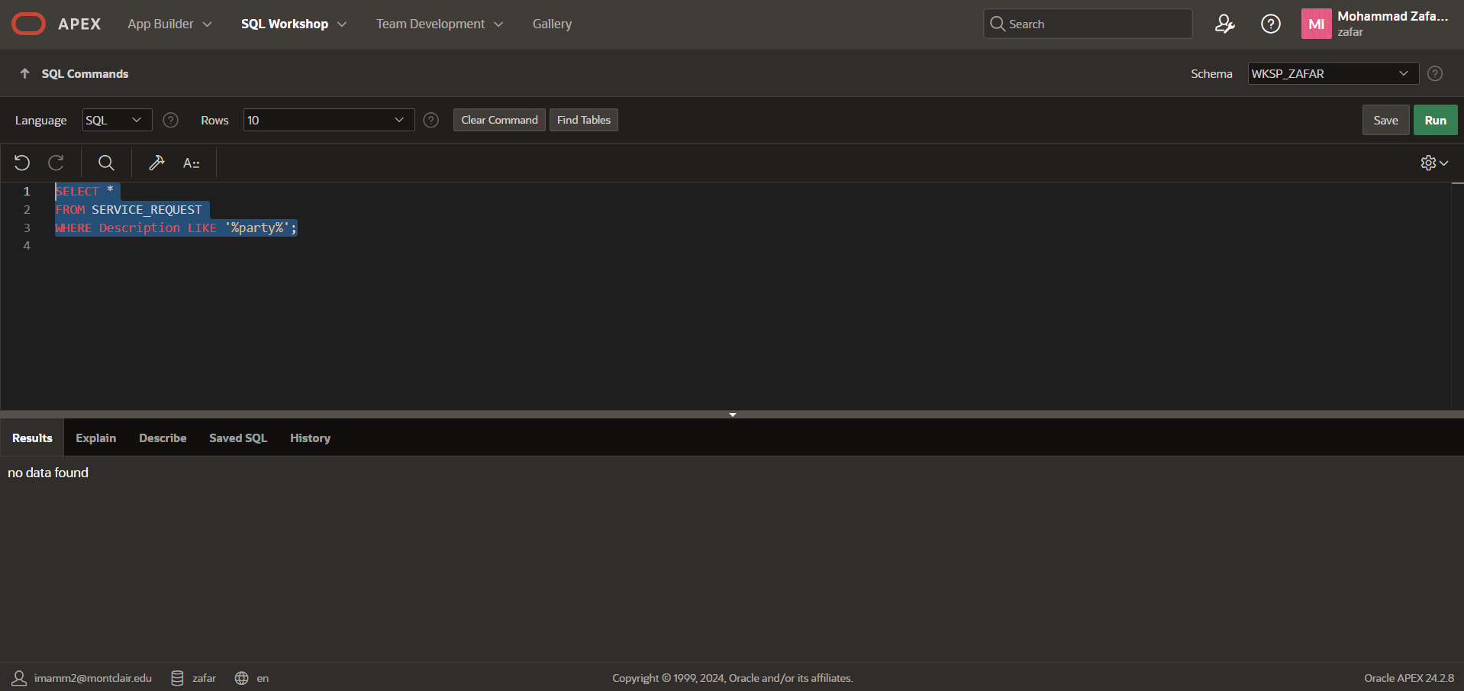

Multiple Table Queries:
Q1.) For every condo, list the location number, unit number, condo fee, owner number, owner's first name, and owner's last name.
SQL CODE:
SELECT
CU.LOCATION_NUM,
CU.UNIT_NUM,
CU.CONDO_FEE,
CU.OWNER_NUM,
O.FIRST_NAME,
O.LAST_NAME
FROM CONDO_UNIT CU
JOIN OWNER O ON CU.OWNER_NUM = O.OWNER_NUM;

Screenshot:
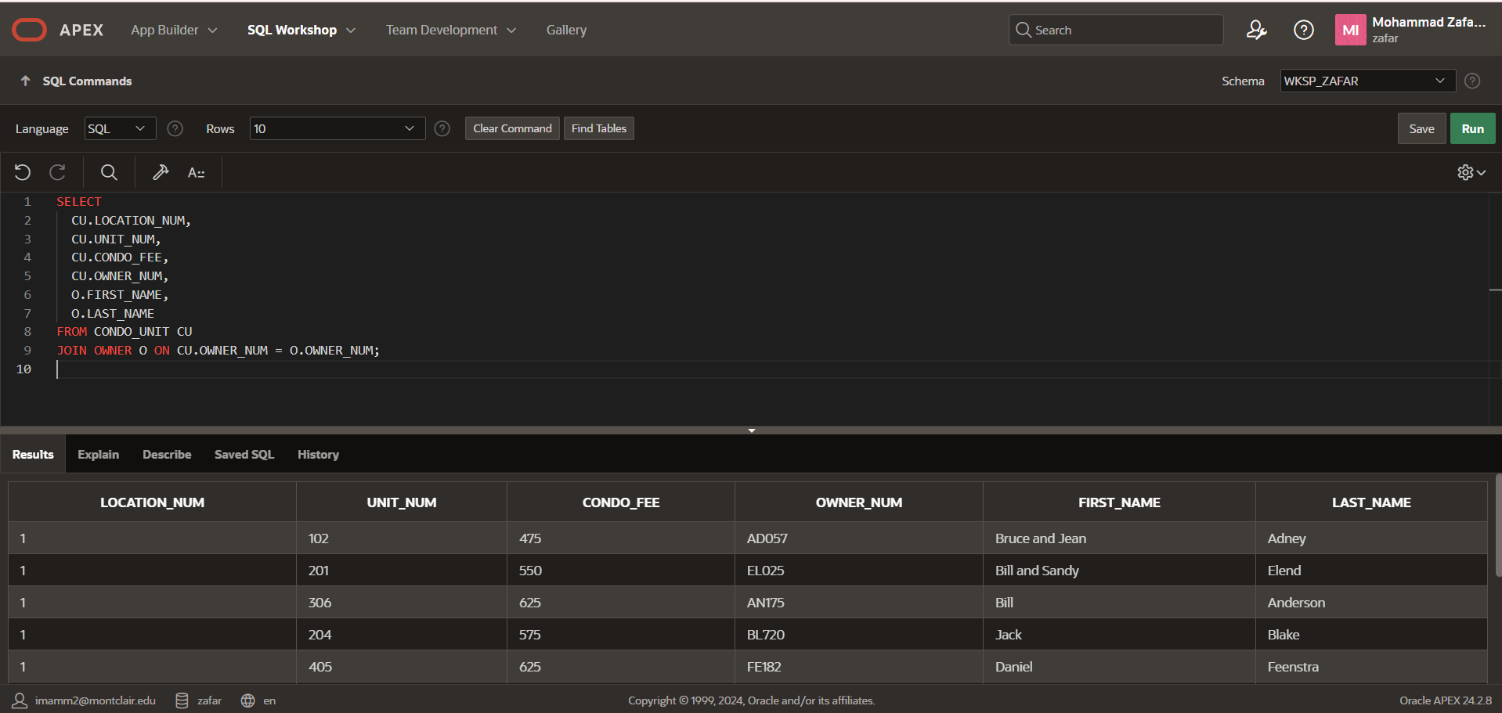

Q2.)List the condo ID, description, and status for every completed or open service request related to janitorial work.
SQL CODE:
SELECT
sr.CONDO_ID,
sr.DESCRIPTION,
sr.STATUS
FROM SERVICE_REQUEST sr
JOIN SERVICE_CATEGORY sc
ON sr.CATEGORY_NUM = sc.CATEGORY_NUM
WHERE sc.CATEGORY_DESCRIPTION = 'Janitorial'
AND sr.STATUS IN ('Open','Completed');

Screenshot:
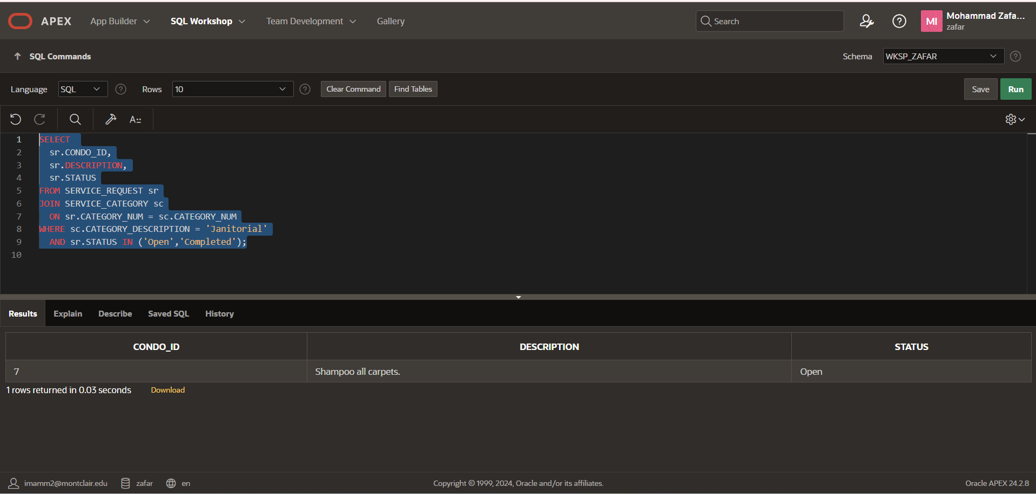

Q.4) List the first and last names of all owners who have a three-bedroom condo. Use the IN operator in your query.
SQL CODE: SELECT FIRST_NAME, LAST_NAME
FROM OWNER
WHERE OWNER_NUM IN (
SELECT OWNER_NUM
FROM CONDO_UNIT
WHERE BDRMS = 3
);
Screenshot:
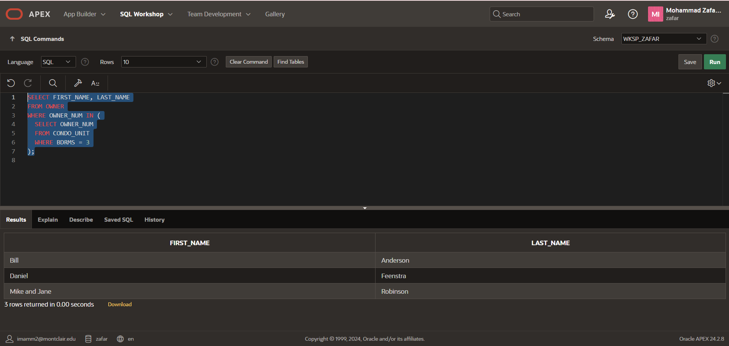

Q.5). Repeat Exercise 4 (which asked to list the first and last names of all owners who have a three-bedroom condo), but this time use the EXISTS operator in your query.
SQL CODE:
SELECT FIRST_NAME, LAST_NAME
FROM OWNER o
WHERE EXISTS (
SELECT 1
FROM CONDO_UNIT c
WHERE c.OWNER_NUM = o.OWNER_NUM
AND c.BDRMS = 3
);

Screenshot:
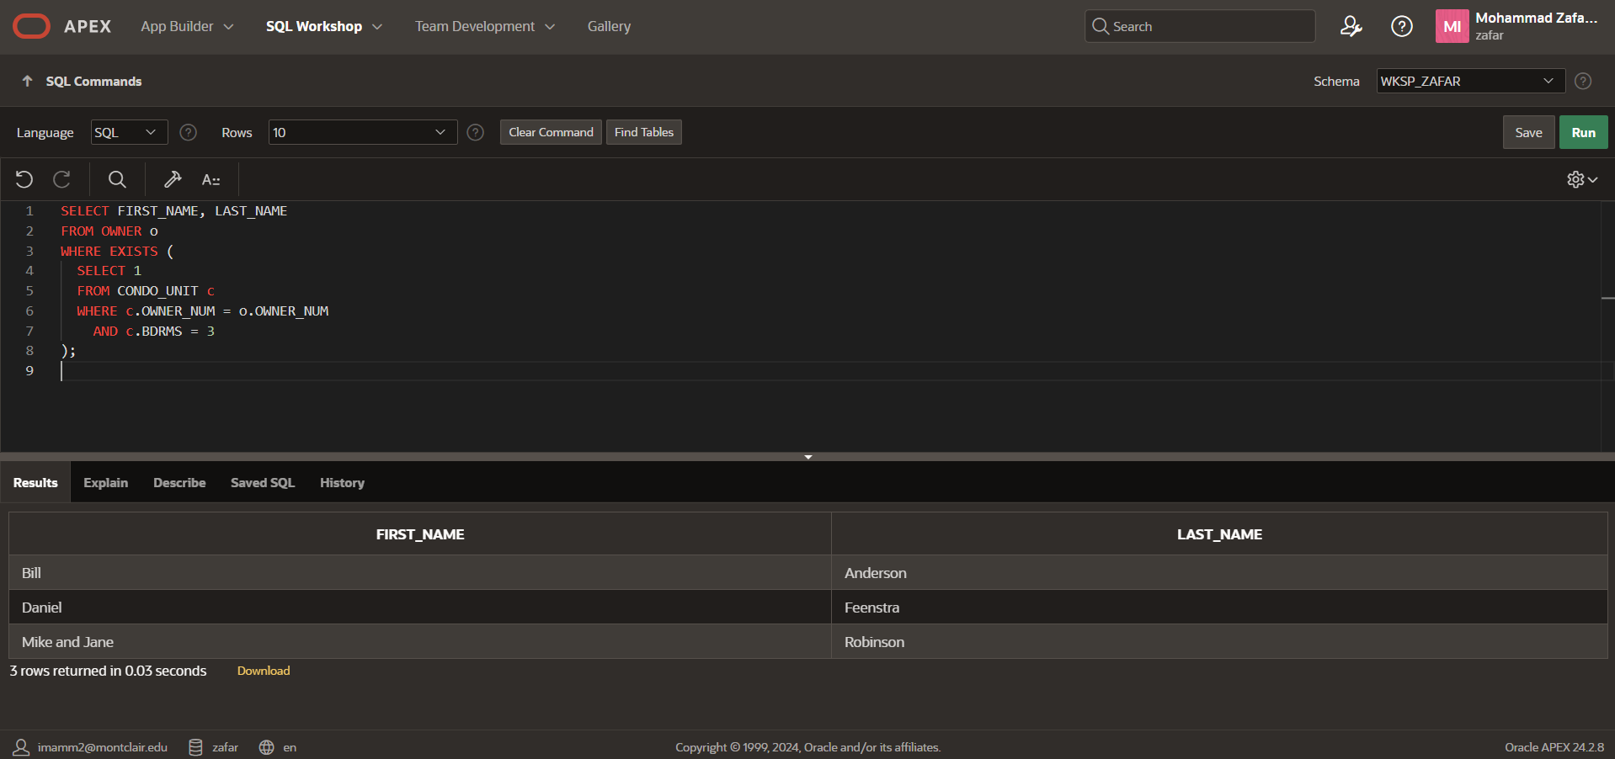

Q6.)Rewritten question: List the unit-number pairs for condos that have the same square footage. For each matching pair, show the first unit number and the second unit number, ensuring the first is less than the second to avoid duplicates, and sort by the first unit number (major key) then the second (minor key).
SQL CODE: SELECT
c1.UNIT_NUM AS UNIT_NUM_1,
c2.UNIT_NUM AS UNIT_NUM_2
FROM CONDO_UNIT c1
JOIN CONDO_UNIT c2
ON c1.SQR_FT = c2.SQR_FT
AND c1.UNIT_NUM < c2.UNIT_NUM
ORDER BY
UNIT_NUM_1,
UNIT_NUM_2;

Screen Shot:

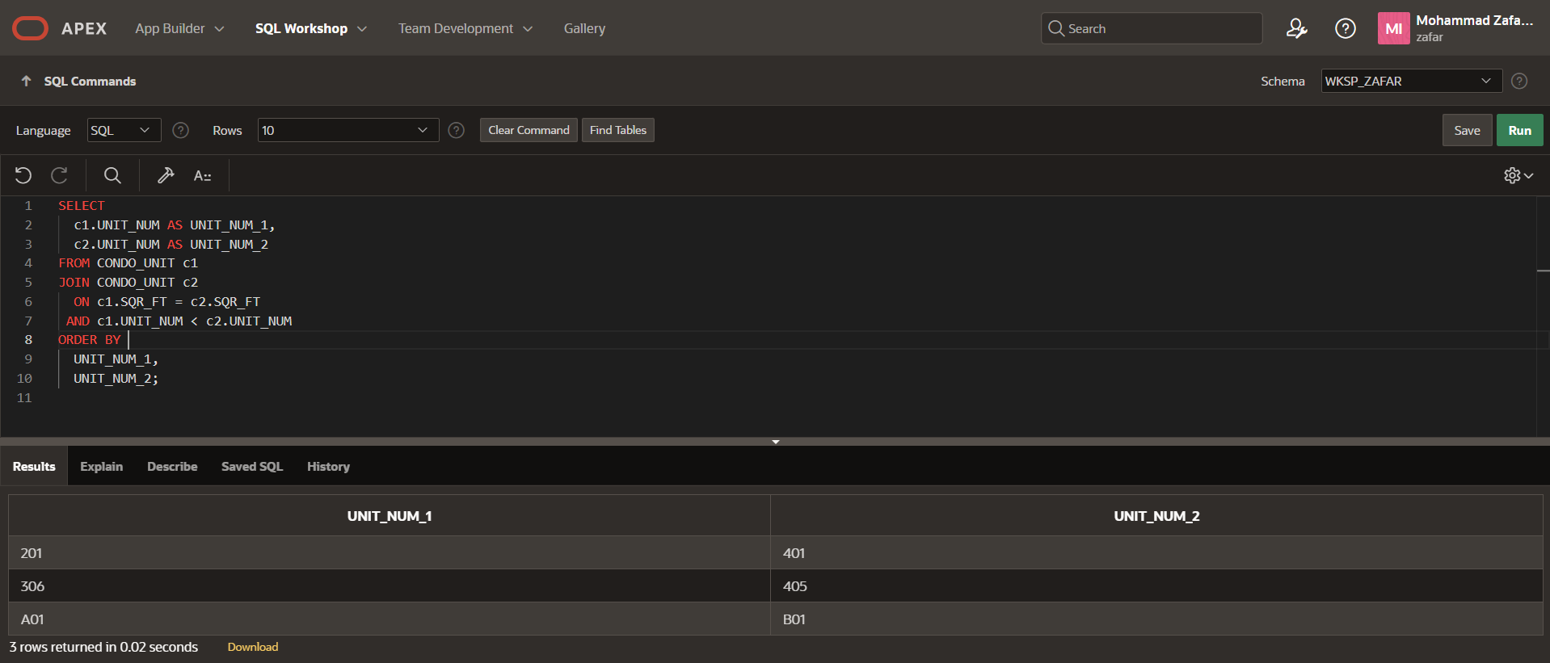

Q.7) List the square footage, owner number, owner last name, and owner first name for each condo in location number 1.
SQL CODE:
SELECT cu.SQR_FT, cu.OWNER_NUM, o.LAST_NAME, o.FIRST_NAME
FROM CONDO_UNIT cu
JOIN OWNER o ON cu.OWNER_NUM = o.OWNER_NUM
WHERE cu.LOCATION_NUM = 1;

Screenshot:

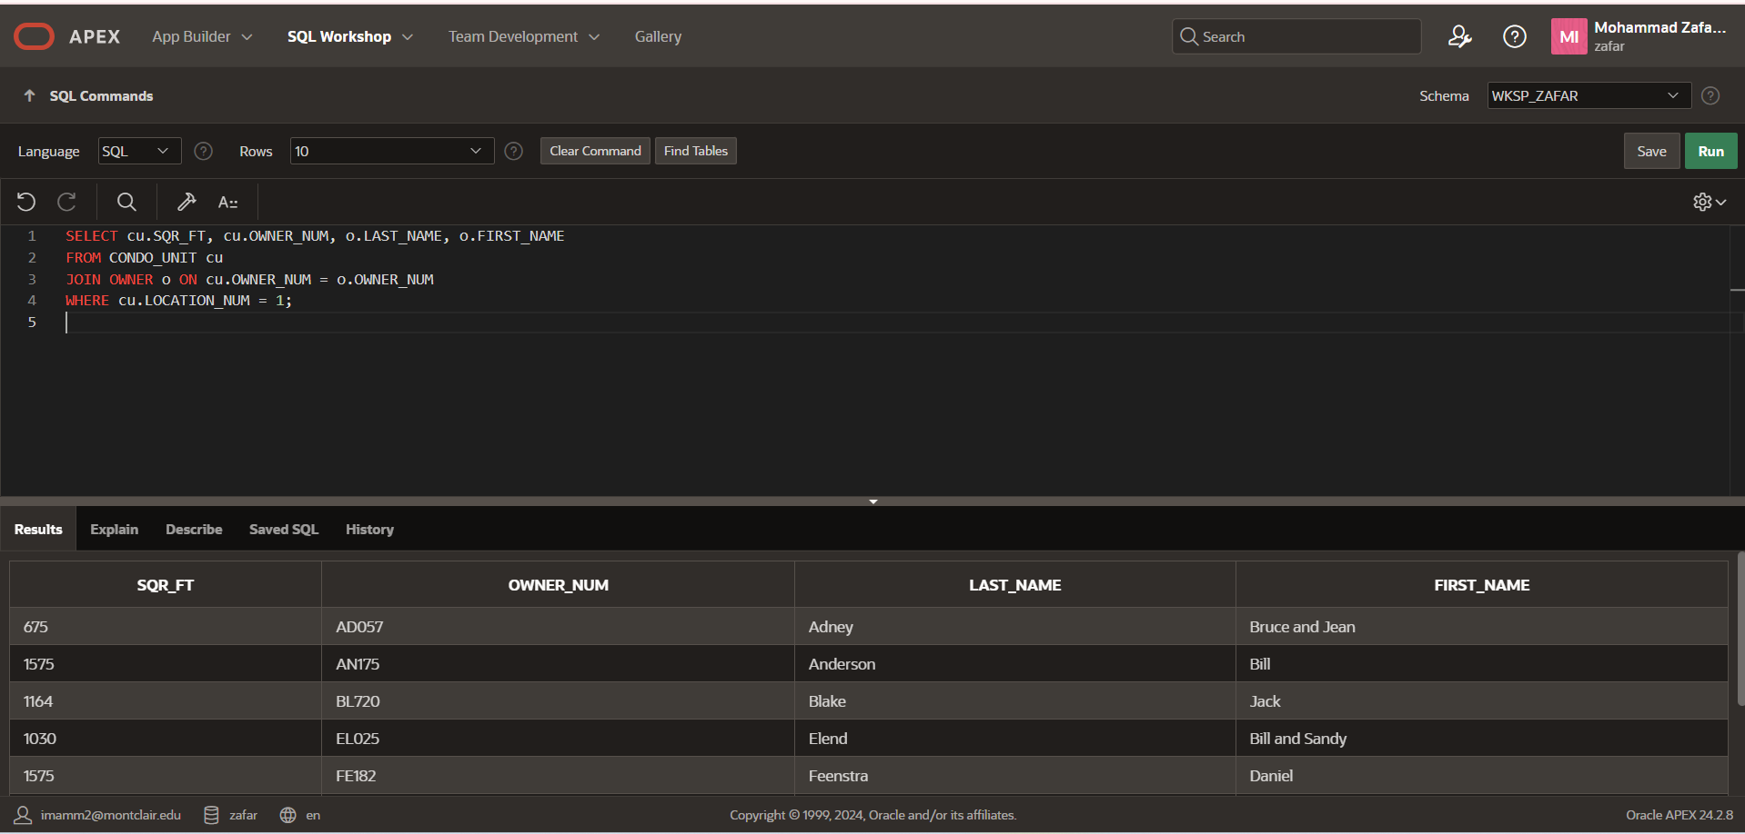

Q.8) Repeat Exercise 7, but this time include only those condos with three bedrooms. List the square footage, owner number, owner last name, and owner first name for each condo in location number 1 that has three bedrooms.

SQL CODE:
SELECT cu.SQR_FT, cu.OWNER_NUM, o.LAST_NAME, o.FIRST_NAME
FROM CONDO_UNIT cu
JOIN OWNER o ON cu.OWNER_NUM = o.OWNER_NUM
WHERE cu.LOCATION_NUM = 1 AND cu.Bdrms =3;

Screen Shot:
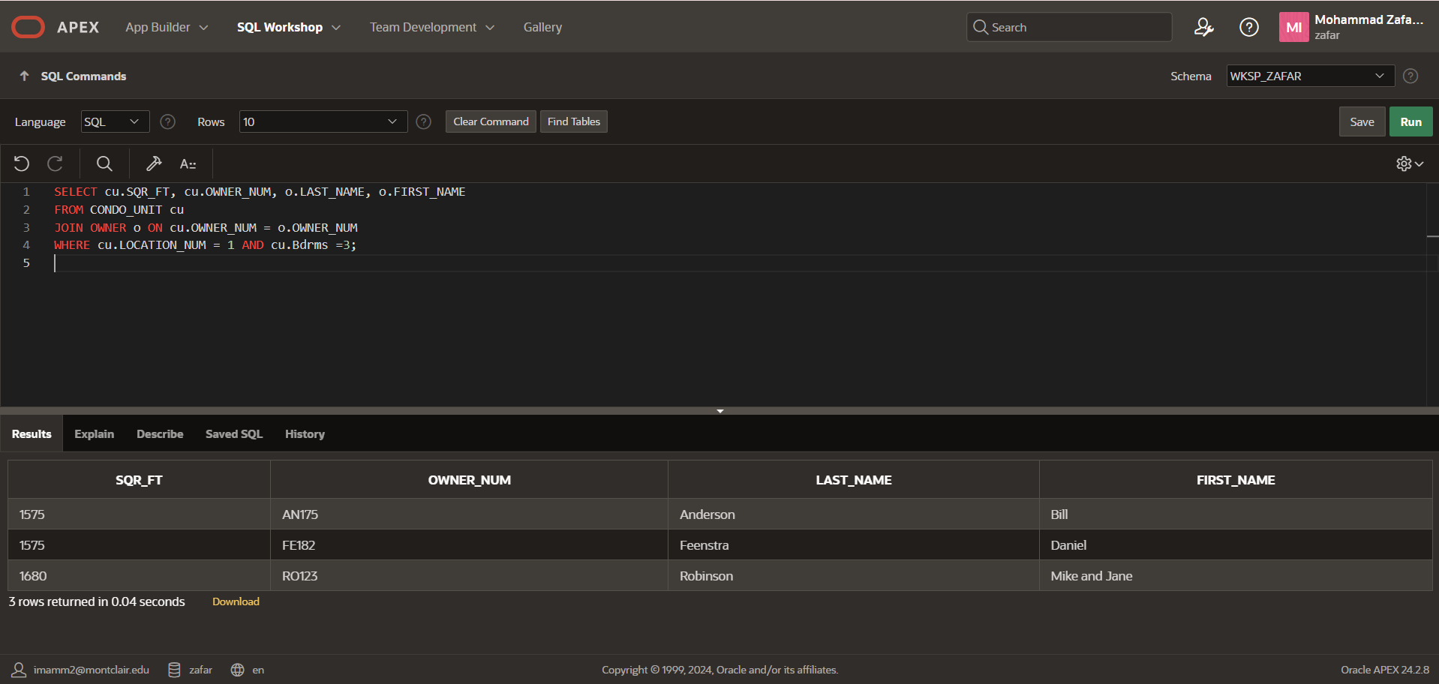

Q.9). List the location number, unit number, and condo fee for condos whose owners live in Boyton or own one-bedroom condos.
SQL CODE: SELECT
cu.LOCATION_NUM,
cu.UNIT_NUM,
cu.CONDO_FEE
FROM CONDO_UNIT cu
JOIN OWNER o
ON cu.OWNER_NUM = o.OWNER_NUM
WHERE UPPER(o.CITY) = 'BOYTON'
OR cu.BDRMS = 1
ORDER BY cu.LOCATION_NUM, cu.UNIT_NUM;

Screen Shot:
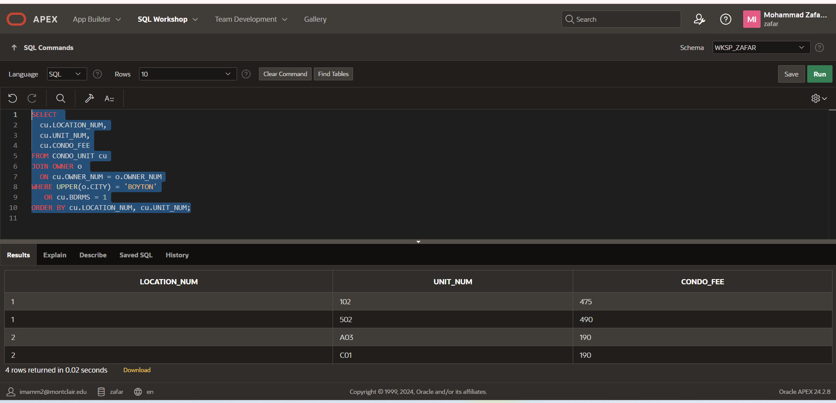

Q.10). List the location number, unit number, and condo fee for condos whose owners live in Bowton and who own a one-bedroom condo.

SQL CODE:
SELECT cu.LOCATION_NUM, cu.UNIT_NUM, cu.CONDO_FEE
FROM CONDO_UNIT cu
JOIN OWNER o ON cu.OWNER_NUM = o.OWNER_NUM
WHERE UPPER(o.CITY) = 'BOWTON'
AND cu.BDRMS = 1
ORDER BY cu.LOCATION_NUM, cu.UNIT_NUM;

Screen Shot:
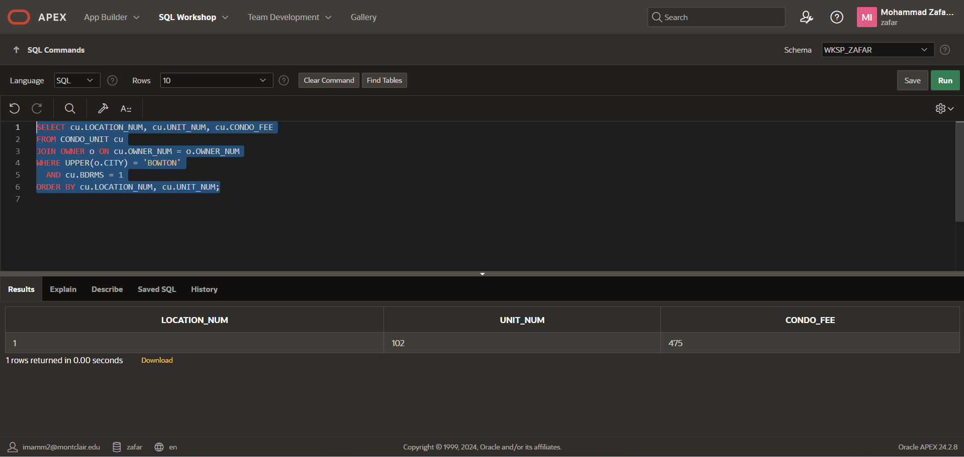

Q.11) List the location number, unit number, and condo fee for condos whose owners live in Bowton but do not own any one-bedroom condos.

SQL Code:
SELECT cu.LOCATION_NUM, cu.UNIT_NUM, cu.CONDO_FEE
FROM CONDO_UNIT cu
JOIN OWNER o ON cu.OWNER_NUM = o.OWNER_NUM
WHERE UPPER(o.CITY) = 'BOWTON'
AND cu.OWNER_NUM NOT IN (
SELECT OWNER_NUM FROM CONDO_UNIT WHERE BDRMS = 1
)
ORDER BY cu.LOCATION_NUM, cu.UNIT_NUM;

Screen Shot:
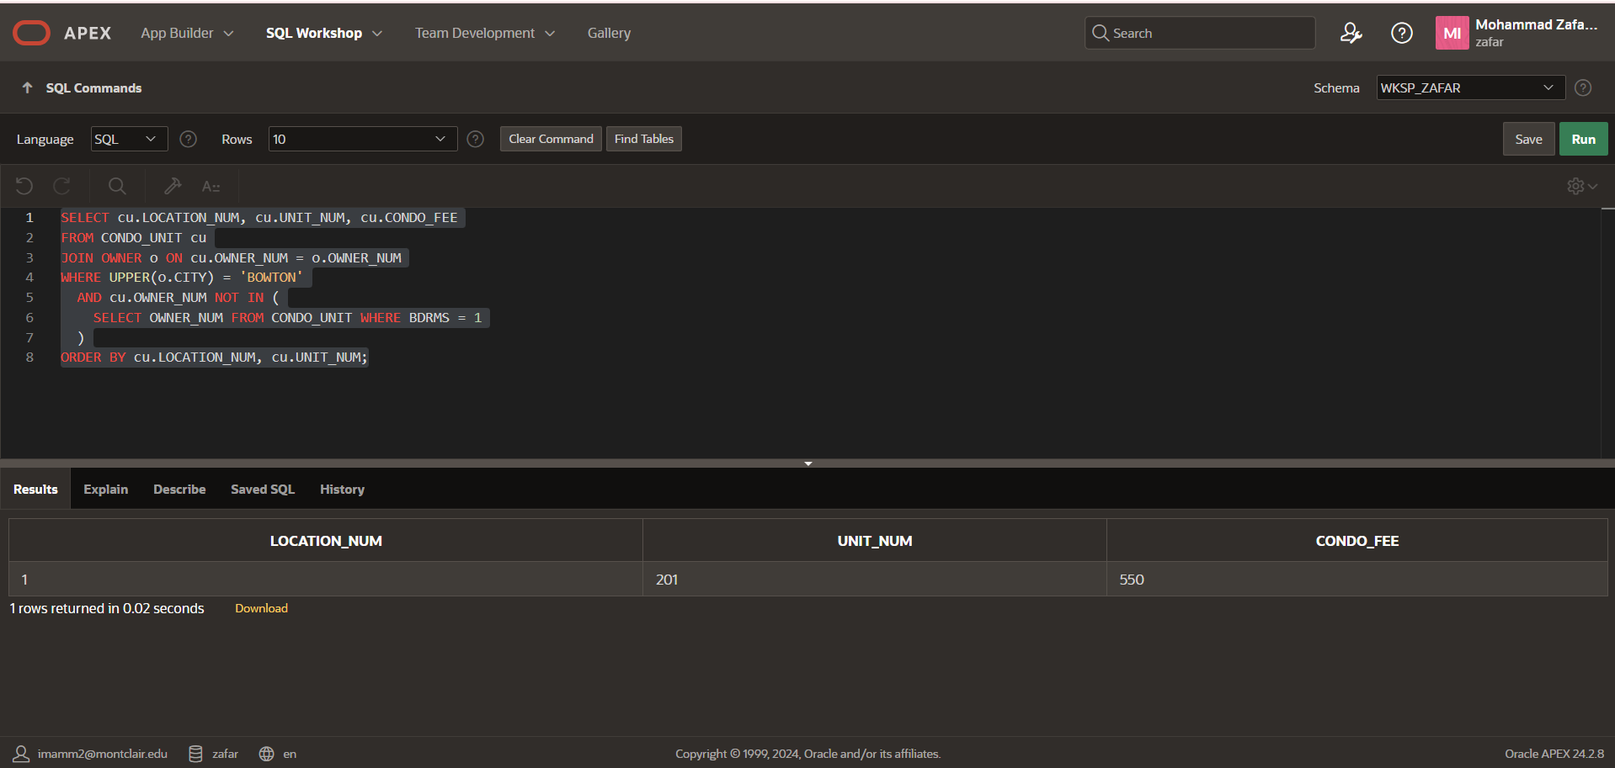

Q.12). List the service ID and condo ID for each service request whose estimated hours is greater than the estimated hours of every service request where the category number is 5.
SQL Code:
SELECT SERVICE_ID, CONDO_ID
FROM SERVICE_REQUEST
WHERE EST_HOURS > (
SELECT MAX(EST_HOURS)
FROM SERVICE_REQUEST
WHERE CATEGORY_NUM = 5
);

Screenshot:
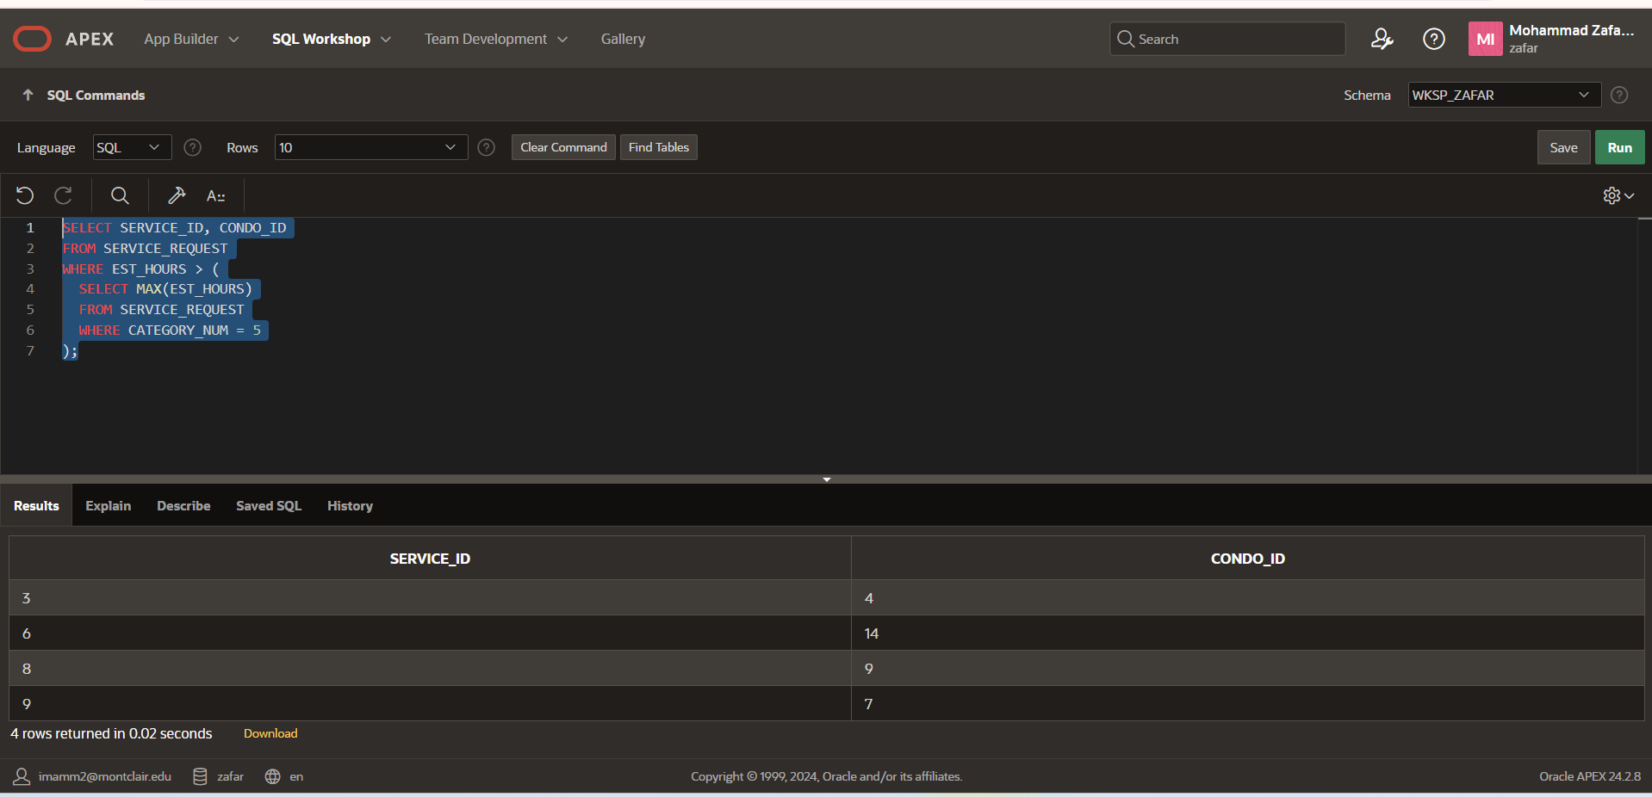

Q.13) Find the service ID and condo ID for each service request where the estimated hours are greater than the estimated hours of every service request with category number 5.
SQL CODE:
SELECT SERVICE_ID, CONDO_ID
FROM SERVICE_REQUEST
WHERE EST_HOURS > ALL (
SELECT EST_HOURS
FROM SERVICE_REQUEST
WHERE CATEGORY_NUM = 5
);

Screen Shot: 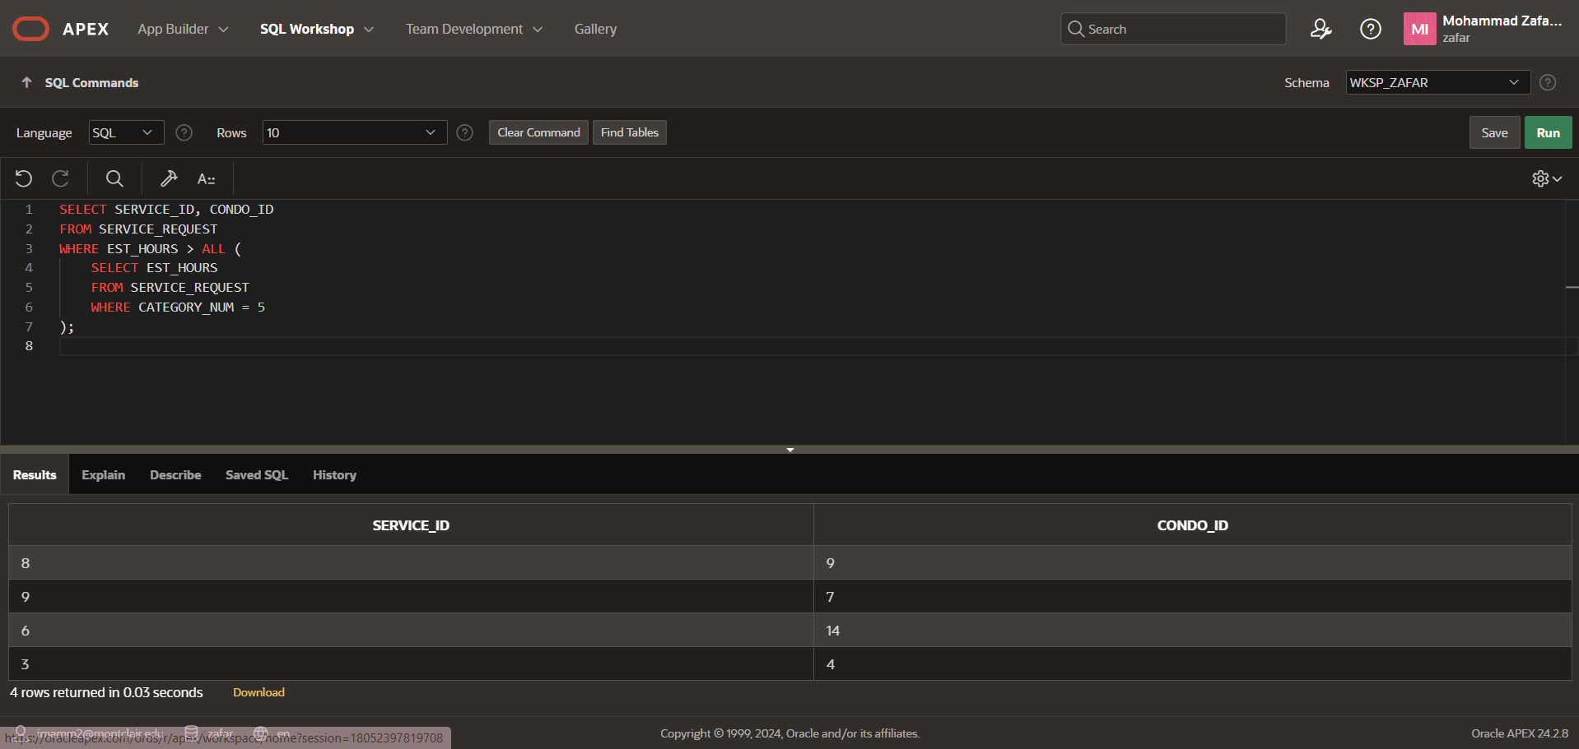

Q.14). List the condo ID, square footage, owner number, service ID, number of estimated hours, and number of spent hours for each service request where the category number is 4.

SQL CODE:
SELECT cu.CONDO_ID,
cu.SQR_FT,
cu.OWNER_NUM,
sr.SERVICE_ID,
sr.EST_HOURS,
sr.SPENT_HOURS
FROM CONDO_UNIT cu
JOIN SERVICE_REQUEST sr ON cu.CONDO_ID = sr.CONDO_ID
WHERE sr.CATEGORY_NUM = 4;

Screenshot:
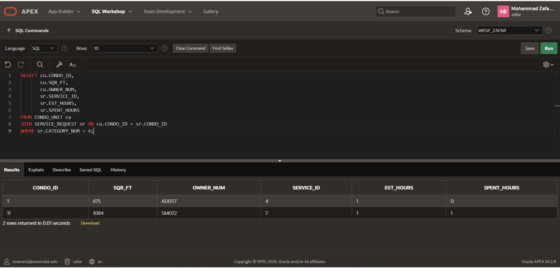

Q 15.)Repeat Exercise 14, but this time include every condo in the results—even if the condo currently has no service requests for category 4. If there are no such requests for a condo, show NULL for the service request details.

SQL CODE: SELECT cu.CONDO_ID,
cu.SQR_FT,
cu.OWNER_NUM,
sr.SERVICE_ID,
sr.EST_HOURS,
sr.SPENT_HOURS
FROM CONDO_UNIT cu
LEFT JOIN SERVICE_REQUEST sr
ON cu.CONDO_ID = sr.CONDO_ID
AND sr.CATEGORY_NUM = 4;
Screen Shot:
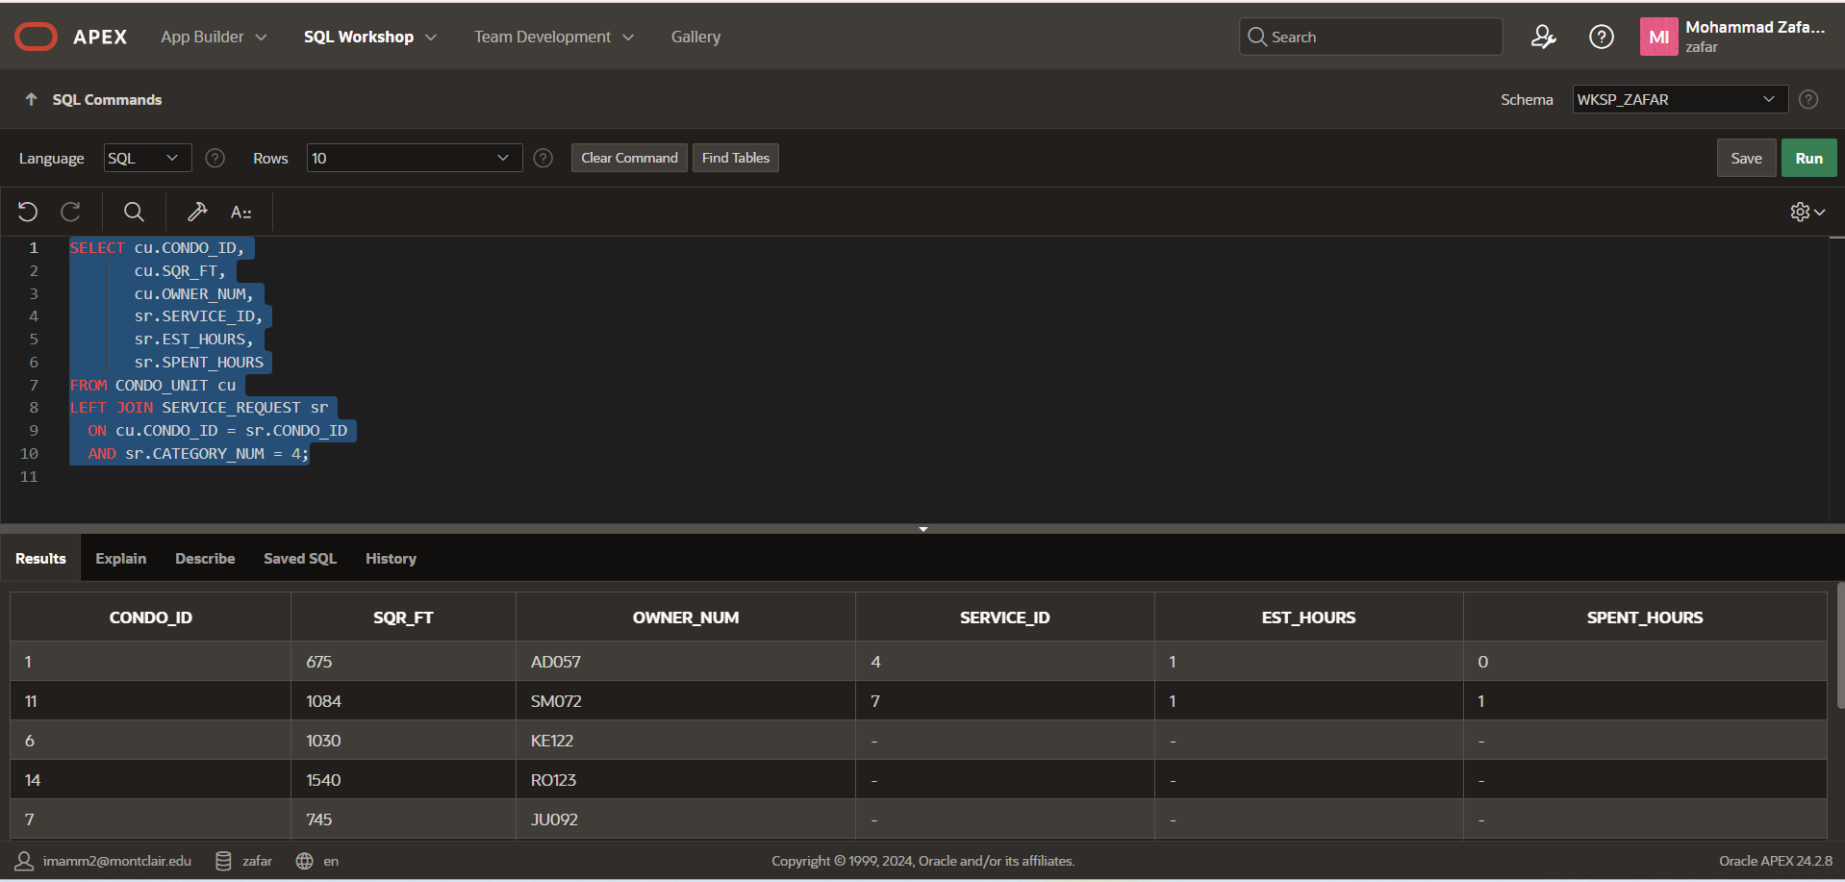

Q 16.) Repeat Exercise 15 using a different SQL command to obtain the same result. What is the difference between the two commands?

SQL CODE: SELECT cu.CONDO_ID, cu.SQR_FT, cu.OWNER_NUM, sr.SERVICE_ID, sr.EST_HOURS, sr.SPENT_HOURS
FROM CONDO_UNIT cu, SERVICE_REQUEST sr
WHERE cu.CONDO_ID = sr.CONDO_ID
AND sr.CATEGORY_NUM = 4

UNION

SELECT cu.CONDO_ID, cu.SQR_FT, cu.OWNER_NUM, NULL AS SERVICE_ID, NULL AS EST_HOURS, NULL AS SPENT_HOURS
FROM CONDO_UNIT cu
WHERE cu.CONDO_ID NOT IN (
SELECT CONDO_ID FROM SERVICE_REQUEST WHERE CATEGORY_NUM = 4
);
SCREEN SHOT:
